**Ping pong game**

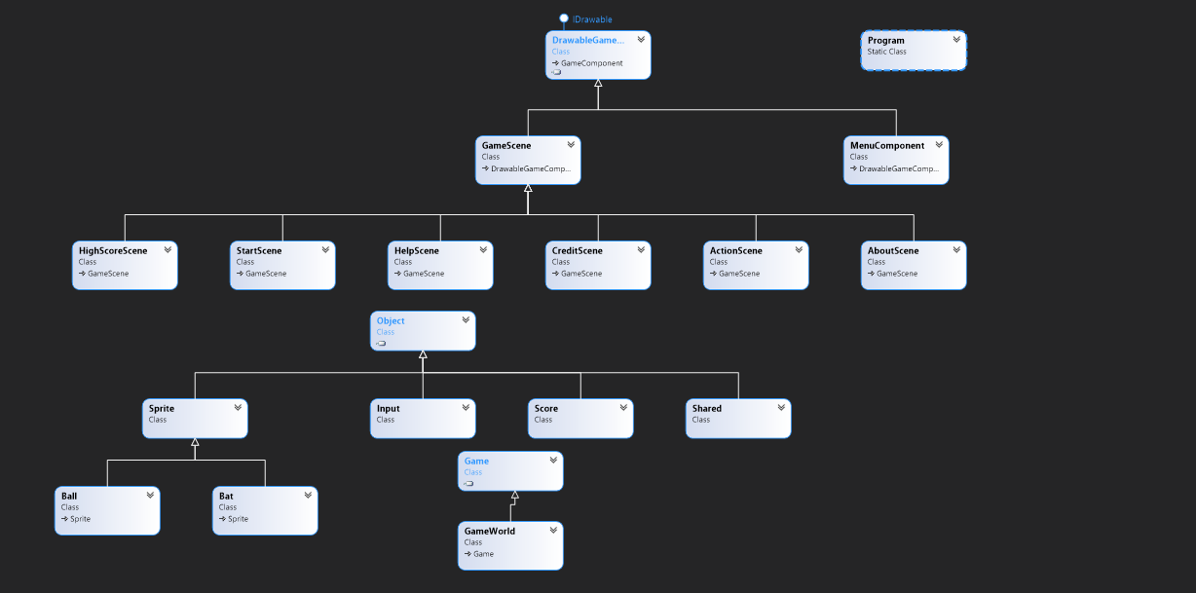**Class Diagram:**

**I have created pong game for two player:**

**Player 1 Controller: W and S Key**

**Player 2 Controller: Up and Down Arrow**

**To start the game click space button**

**I have created menu part as per class example to exit from particular menu item**

**I have added 5 screens.**

**Password for game is 123456.**

**Reference:**

[**https://youtu.be/MMWbDFzst58**](https://youtu.be/MMWbDFzst58)

**I have used few parts from this tutorial.**

**Image:**

**<a href='https://www.freepik.com/photos/background'>Background photo created by kjpargeter - www.freepik.com</a>**